# Pin Mapping

|  |  |  |
| --- | --- | --- |
| MCU Pin | Pin Mode | Functional Description |
| PC8 | GPIO_Input | Detects state of window 1. |
| PC9 | GPIO_Input | Detects state of window 2. |
| PB2 | GPIO_Input | Detects state of window 3. |
| PB1 | GPIO_Input | Detects state of window 4. |
| PC3 | GPIO_Input | Detects state of door 1. |
| PA4 | GPIO_Input | Detects state of door 2. |
| PC11 | GPIO_Output | Toggles window 1 Arm Led |
| PC12 | GPIO_Output | Toggles window 1 Disarm Led |
| PB4 | GPIO_Output | Toggles window 2 Arm Led |
| PB5 | GPIO_Output | Toggles window 2 Disarm Led |
| PB8 | GPIO_Output | Toggles window 3 Arm Led |
| PB9 | GPIO_Output | Toggles window 3 Disarm Led |
| PC0 | GPIO_Output | Toggles window 4 Arm Led |
| PC1 | GPIO_Output | Toggles window 4 Disarm Led |
| PA1 | GPIO_Output | Toggles door 1 Arm Led |
| PA0 | GPIO_Output | Toggles door 1 Disarm Led |
| PA7 | GPIO_Output | Toggles door 2 Arm Led |
| PA6 | GPIO_Output | Toggles door 2 Disarm Led |
| PC2 | GPIO_Output | Toggles system Alarm |
| PB6 | TIM4_CH1 | Triggers interrupt on rising and falling edge of distance sensor 1 |
| PB7 | TIM4_CH2 | Triggers interrupt on rising and falling edge of distance sensor 2 |
| PA10 | GPIO_Output | Voltage level for keyboard column 1 |
| PA11 | GPIO_Output | Voltage level for keyboard column 2 |
| PA12 | GPIO_Output | Voltage level for keyboard column 3 |
| PB12 | GPIO_EXTI12 | Triggers interrupt on row 1 press |
| PB13 | GPIO_EXTI13 | Triggers interrupt on row 2 press |
| PB14 | GPIO_EXTI14 | Triggers interrupt on row 3 press |
| PB15 | GPIO_EXTI15 | Triggers interrupt on row 4 press |
| PC4 | GPIO_Output | Toggles front door light |
| PC5 | GPIO_Output | Toggles back door light |
| PC6 | USART6_TX | Transmitter to LCD. |
| PC7 | USART6_RX | Receiver from virtual terminal |
| PA15 | TIM2_CH1 | Pulse for polling distance sensor 1 |
| PB10 | TIM2_CH3 | Pulse for polling distance sensor 2 |
| PB0 | GPIO_Output | Toggles buzzer. |

# MCU Resources

|  |  |
| --- | --- |
| MCU Resource | Functional Description |
| USART6 | Communicates with devices that follow UART standard such as LCD and Virtual Terminal. |
| TIM2 | Generates pulses to poll the distance sensors. |
| TIM4 | Generates interrupts on rising and falling edges of distance sensor echos. |
| TIM10 | Generates an interrupt every second to increment the clock and also check for activation delay. |
| GPIO | Interfaces with any device that simply needs an on/off signal to operate. |

# Test Cases

## {Sensor Leds/Open-Close sensors}

### Will change sensor status via virtual terminal and show that it updates the LEDs in order to prove functionality. (Red = Alarm, Blue = Arm, Green = Disarm). Then open one of the sensors when armed to demonstrate alarm led. (Must type slow in virtual terminal since proteus is so slow)

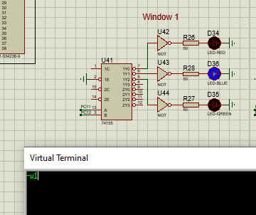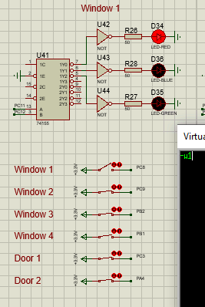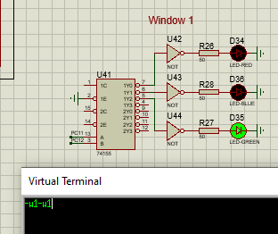

We can then see the system indicator flashing when system is in alarm state:

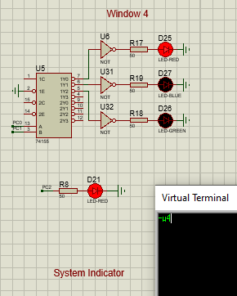

## {LCD}

### Will change sensor status via virtual terminal and show that it updates the LCD in order to prove functionality.

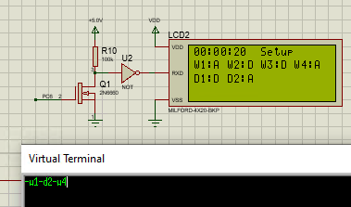

## {Keyboard}

### Will type in password to put system in disarmed or alarm state to prove functionality.

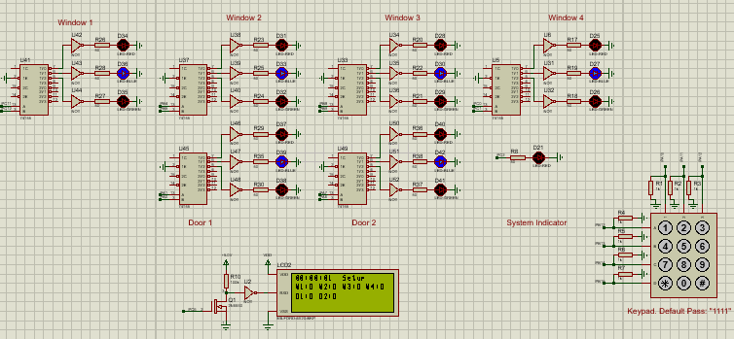

## {Buzzer}

### Will put system in alarm state to prove functionality.

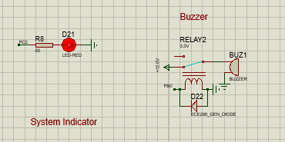

## {Distance Sensor/Door Lights}

### Once able to get this to work as MCU would sink echo voltage from the distance sensor. We could try a comparator to remedy the issue but simply ran out of time.

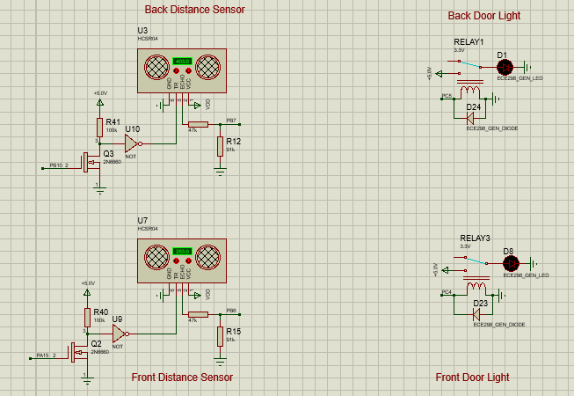

## {Virtual Terminal}

### Functionality was proven via the previous examples.